Driven to distraction:
a submission on reducing tourist accidents

Prepared by
Clive Matthew-Wilson, Editor, dogandlemon.com,
October, 2014

Precis
There have also been a number of high profile accidents involving tourists crashing on New Zealand roads, with nearly 600 road accidents last year, resulting in death or injury, caused by foreign visitors.
The Paris-based Fédération Internationale de l'Automobile (FIA), had the following to say about risks that tourist drivers face in a foreign country:
Research undertaken in Australia, New Zealand and the UK on the underlying causes has identified a number of additional tourist-specific risks (e.g. unfamiliarity, disorientation, distraction and fatigue). Tourists are more at risk when they are not well prepared, where there is insufficient harmonization in road safety practices (e.g.: pedestrian priority at pedestrian crossings) or they are involved in risky behavior (e.g.: speeding, drink-driving and not wearing a seat-belt or crash helmet).

The New Zealand situation
The situation in New Zealand is often more complex than it first appears. While the percentage of accidents involving tourist drivers has been slowly trending up for the past 20 years, it is still lower than it was in 2012.
Research conducted by the Herald, using the New Zealand Transport Agency’s (NZTA) Crash Analysis System (CAS), noted that in 1994, death or injury accidents involving tourists were just 0.7%. By 2012, this figure had grown to 4.2%, largely due to the increase in tourist drivers.
However, in 2013, this figure had dropped to 2.9%, although these recent variations in percentages may be simply the normal variations that mysteriously affect the road toll, without affecting the overall trend.
One significant factor is location of accidents: while the national figure is quite low, in certain locations, such as Southland, the percentage is around 25%; an alarming figure given the relatively small amount of traffic using those roads.
Although the total combination of causes and effects are far from clear, it appears that the high numbers of tourist accidents in this area are a combination of:
- Vehicles
A significant number of accidents appear to involve camper vans, which many tourists are unfamiliar with and which require greater skills than most passenger cars.
- Confusion
Many tourists come from countries where motor vehicles drive on the opposite side of the road. There is often confusion during certain manoeuvres, such as navigating through intersections, combined with a tendency for the driver to instinctively lurch to the wrong side of the road in emergency situations.
- Unfamilarity with high-speed rural roads
Many people from countries like China have no experience with driving on rural roads, and also with driving at open road speeds. This unfamiliarity appears to be a factor in a number of accidents.
- Fatigue
Longer term insidious effects of jetlag appear to affect many tourist drivers. While there is an obvious risk in a driver using a vehicle a short time after arriving from a long overseas flight, there appear to be longer-term issues as well.
Where a person who is tired and confused after a long flight might make allowances for these obvious factors, a person who has been in the country for a week or ten days might falsely believe they are now free from such issues.
- Time pressures
For many Asian cultures, a trip overseas is a once-in-a-lifetime experience, never to be repeated, and often part of important life changes, such as a honeymoon. Many such tourists will only be able to take a vacation with the permission of their employer, and even then, only for a short amount of time, such as a week or perhaps two weeks. These tourists are likely therefore to be under severe pressure to make the best use of a very limited holiday.
The fatigue problem may be exacerbated by the fact that many tourists appear to underestimate the time required to explore this country properly. Instead, they may rush from tourist destination to tourist destination, without ever taking the time to relax sufficiently to catch up on sleep.

Cultural attitudes to danger
Some cultures, including many from Asia and those from the Indian sub-continent, believe that life or death in any situation is a result of chance, fate or karma (the divine law of cause and effect). To this group, if a fatal accident occurs, it is because it is their time to die. It cannot be prevented. This perhaps explains the number of visitors from the Indian sub-continent, who have had vehicles seized off them by police after extremely reckless driving, which to the drivers concerned was simply normal behavior in a culture where visible death is an everyday occurrence.
An Indian tourist reported for driving in the incorrect lane at least four times in an afternoon told the Queenstown District Court he did not know what the centre lines on the road were for.
Several members of the public called police about Singh's driving between Beaumont and Queenstown after he was seen crossing the centre line, passing cars on double yellow lines and found fully in the opposite lane on blind corners at least four times.
At least two drivers had to take evasive action to avoid crashing.

Solutions
The Government, perhaps fearful of offending tourists, especially those from major trading partners, appears to be afraid of legislating to make it more difficult for unsuitable foreign drivers to get behind the wheel of a rental car. Instead, the New Zealand Transport Agency, police, tourist organisations are conducting a number of low-key strategies for solving the problem of tourist crashes. The main points of focus are education of the rental drivers, together with the staff and management of rental firms.
The rental firms themselves are conducting a number of impressive-sounding initiatives, but which are unlikely to fully address the issue, for the reasons outlined below.
The stated initiatives of the tourism industry include:
• Observing the driving of those who appear low on confidence.
• A video on New Zealand roads and driving, which can be sent to clients when they book.
• Cancelling the contract if police have serious concerns about a tourist's driving.
• A scheme to ensure a driver turned away or banned from one company cannot sign up with another.

There are a number of problems with this approach:

No mandatory code of road safety practice for rental industry
There is no coherent code of road safety practice across the rental car industry, and no requirement that individual operators adhere to such codes as may be suggested by groups such as NZTA.
Moreover, there is widespread suspicion that rental companies are placing more emphasis on token gestures, such as brochures and short educational videos, rather than taking effective steps to filter out unsuitable drivers. Rental car companies appear to be more concerned with meeting rental sales quotas than in reducing the risk of vehicle accidents.
Lastly, because there is no requirement that rental operators adhere to such codes of practice as may exist, there is a suspicion that foreign drivers who are turned down by one rental agency, will simply go to another.
The initiative above, in which the rental industry groups plan: “A scheme to ensure a driver turned away or banned from one company cannot sign up with another” has no legal standing and would require 100% compliance across the industry. Otherwise, as stated above, after being turned down by one rental firm, the rejected driver could simply go to another firm.
This was the case with Dutch businessman, Johannes Jacobus Appelman, 52, who, on Queen's Birthday weekend of 2014, killed three people.
Appelman, arrived in Christchurch on May 30 and rented a car, then crashed it a few kilometres from the airport while adjusting the GPS. The rental firm cancelled his contract after the accident. The following day, Appelman hired a Subaru from another firm and, at about 3.55 pm, drove through a stop sign at a rural intersection near Rakaia at about 100km/h, killing Sally Vanessa Summerfield, 49, her daughter Ella Yasmin Summerfield, 12, and Ella's friend Abi Hone, 12.

2. Education ineffective
Many of the steps being undertaken by the police, NZTA, tourist bodies and the rental firms, involve education.
There are multiple problems with this approach. The first is that virtually all-available research suggests that the worst drivers believe they are the best drivers. So, assuming that they realise the value of the education being offered, they don’t believe it applies to them.
Secondly, the educational approach assumes a similar cultural view, where road safety is the result of a series of planned and logical steps. However, as stated above, many cultures, including many from Asia and those from the Indian sub-continent, believe that life or death in any situation is a result of chance, fate or karma (the divine law of cause and effect).
This group is unlikely to believe, or grasp, the concepts behind the education that is being offered.
An additional problem is that highly robust research suggests road safety education simply doesn’t work. As with anti-drug education for teenagers, road safety education was based around the assumption that high-risk behavior could be avoided if the persons concerned were informed of the consequences of such behavior.
Unfortunately, it is now widely accepted that anti-drug education for teenagers doesn’t work.
Similarly, The American Insurance Institute for Highway Safety, one of the most respected road safety establishments in the world, collated the results of dozens of other studies over the last 30 years.
Their conclusion:
‘Research indicates that education has no effect, or only a very limited effect, on habits like staying within speed limits, heeding stop signs, and using safety belts.
“Until you check out the facts, who can argue against the benefits of education or training? asks Institute chief scientist, Allan Williams. But when good scientific evaluations are undertaken, most of the driver improvement programmes based on education or persuasion alone are found not to work.”’

Useful steps to lower the tourist road toll

Restrictions on the rental of cars to recently arrived drivers
It is widely accepted that persons who have travelled long distances by plane are high-risk drivers, regardless of whether they originate from the country in which they have arrived.
Given the high risks involved in drivers operating rental vehicles when they are too tired, distracted or impaired, it seems reasonable, and within the safe parameters of the Convention on Road Traffic, to impose restrictions on the operation of rental vehicles within a fixed period from arrival.
For example, it is arguable that no person (including people who are already citizens of this country) who have recently arrived from a foreign country on a flight that exceeds 8 hours (not including time spent at airports), should be allowed to drive a rental vehicle within, say, 24 hours.
Such a restriction would not restrict a person’s ability to arrange a vehicle rental at an international airport; just to drive the vehicle concerned. It seems reasonable to assume that rental car companies can contract to rent vehicles to tourists upon arrival, then send out, say, a minivan to pick up these same tourists from their nearby accommodation 24 hours later.

Centralised control of driver eligibility
One obvious step to help prevent similar accidents in the future, would be a legal requirement that all rental firms immediately notify both the police and a centralised database when a significant accident occurs in a rental vehicle. The rental firms would then have to gain police permission before renting further vehicles to this driver or perhaps group.

Restrictions on who can rent vehicles
Rental car companies exist to make money. While they may dislike having their cars damaged, the fact remains that any restrictions on the renting of motor vehicles may significantly decrease their turnover. Anecdotal evidence suggests that, from the top management to the front counter staff, there is overt or subtle pressure to meet sales targets. This pressure tends to cause rental companies to be strongly resistant to calls to screen prospective drivers more carefully.

Accordingly, there needs to be clear, industry-wide code of practice that specifically requires that the person or company renting a vehicle takes all reasonable steps to ascertain that the person likely to be driving this vehicle be able to do so safely. As with certain health and safety legislation, this requirement would need to carry a serious legal penalty for knowingly renting a vehicle where the driver is clearly a high accident risk.
This is roughly analogous to the principle that an adult who hands a loaded gun to a person who is heavily drunk, is clearly culpable to some degree if this same person then shoots someone.
Responsibility for renting a vehicle to an individual whose ability to handle New Zealand driving conditions appears impaired, rests with both the rental company and the individual who approves the rental of this vehicle to the customer.

Standardised driver cognisance test
New Zealand is a signatory to the 1949 Geneva Convention on Road Traffic and amendments. This Convention has now been ratified by the majority of car-driving nations (but, interestingly, not China).
It is clear that New Zealand’s obligations under the Convention prevent us from requiring that a person entering this country in possession of an International Driving Permit, pass a further theoretical or practical driving test, if the purpose of this test is to add an additional layer to the original test that the driver passed in his or her country of origin.
However, there appears to be a clear right on the part of the signatories to the Convention to impose general conditions on the use of motor vehicles within that country, and also, by implication, general conditions on the rental of vehicles.
Restrictions on the rental of vehicles to unsuitable drivers are currently somewhat arbitrary and appear to vary widely between rental companies. There needs to be a brief, standardised and accurate cognisance test that must be passed by any person who is renting a motor vehicle within three months of arriving in the country. This would include New Zealanders, in order to avoid the impression for such a test implied that foreign drivers were inferior or were being treated in a manner that might be construed as a breach of Convention obligations.
It has been argued by the Government that a cognisance test would breach this country’s obligations under the Convention. This claim does not stand much scrutiny.
Regardless of which country a citizen may naturally reside in, they are still a high risk when fatigued and disoriented by lengthy air travel.

It is surely arguable that no reasonable interpretation of the Convention could suggest that any driver be allowed behind the wheel of a car if he or she is physiologically incapable of driving a vehicle safely.
For example, it is universally accepted that the possession on an International Driving Permit, does not, ipso facto, permit a person to drive while drunk. It is a common law matter that is governed by the laws of that particular country.
It is similarly universally accepted that the authorities in any particular country have both a right and a duty to restrict the use of motor vehicles by someone who is drunk. Therefore, this accepted right must also, ipso facto, allow the authorities to take reasonable tests to ascertain if a driver is under the influence of alcohol, provided these tests are not arbitrary or unreasonable
Such a test may reasonably be defined as a cognisance test. Driver cognisance means ‘the range or scope of knowledge or perception’ and can be divided into three factors: the perception of factors regarding the operation of the vehicle, decision-making regarding these factors and vehicle operation based on these decisions.
Although the definition is relatively recent, the enforcement of traffic regulations through cognisance tests is as old as the motorcar itself. For example, since the early twentieth century, policemen have asked suspected drunk drivers to walk a short distance in a straight line. Failure to do so is taken as an indication that the driver is not sufficiently cognisant to safely operate a motor vehicle.
The cognisance test is a test of physiological competence at the time of the test, not knowledge or ability. For example, a person may have a university degree in road safety factors, but still be too tired, distracted, unaware or impaired to safely operate a motor vehicle.
It is similarly arguable that a rental car company has both a right and an obligation to ensure that drivers are not too tired, distracted, unaware or impaired when they rent and then operate a motor vehicle.
For example, hypothetically, a rental car company might reasonably ask all persons about to drive a rental vehicle, that they walk a short distance in a straight line, to demonstrate that they are not impaired before operating a vehicle. We are not advocating such a test, but this example points to the correct general direction that should be taken in establishing whether or not a driver is capable of safely operating a vehicle.
Just as it both relatively easy and reasonable to test for impairment by alcohol, it is it is both relatively easy and reasonable to test for impairment by fatigue, distraction and general unawareness, provided the test is sufficiently standardised, universal in application and sufficiently discerning to provide useful screening of drivers.
It is now universally accepted that driving while fatigued has similar effects on drivers as driving while drunk. Not only is a fatigued driver more likely to fall asleep while driving, but fatigue also slows reaction times when it comes to responding to hazards on the road. A fatigued driver is much more likely to make poor decisions, but also, for example, miss a traffic control signal such as a stop sign, compared with an alert driver.
Regardless of what is impairing the driver, such impairment appears to be relatively easily tested, if the right criteria are applied.

Structure of the proposed cognisance test
In the 1930s, London Transport suffered an alarming number of accidents involving its bus drivers. Its solution was a crude but effective cognisance test. The test consisted of a small, flat-edged revolving wheel with a wiggly line on its outer surface made of solid dots (which, collectively, loosely resembled a winding road). The prospective bus driver was required to manually move a pointer so that it stayed in contact with this series of dots (see photos below).
Only 40% of prospective London bus drivers could pass this test: the other 60% failed, and were thus not hired. Accidents on London buses dropped substantially, apparently largely due to the success of this cognisance test; that is, its ability to weed out drivers who were, and weren’t capable of safely controlling a bus.
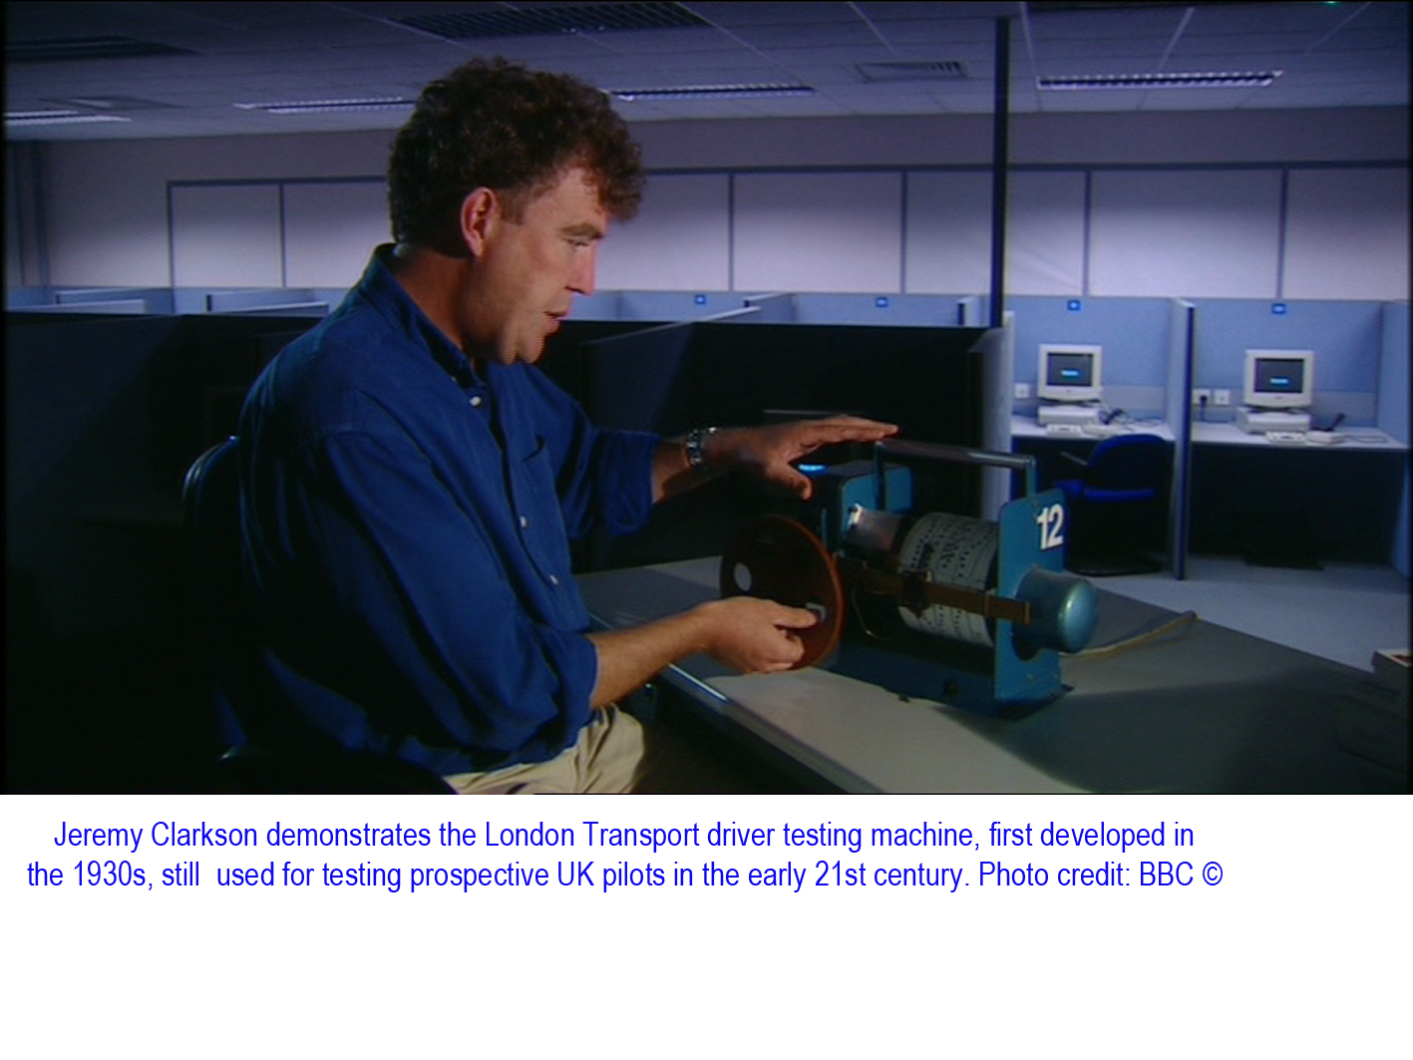
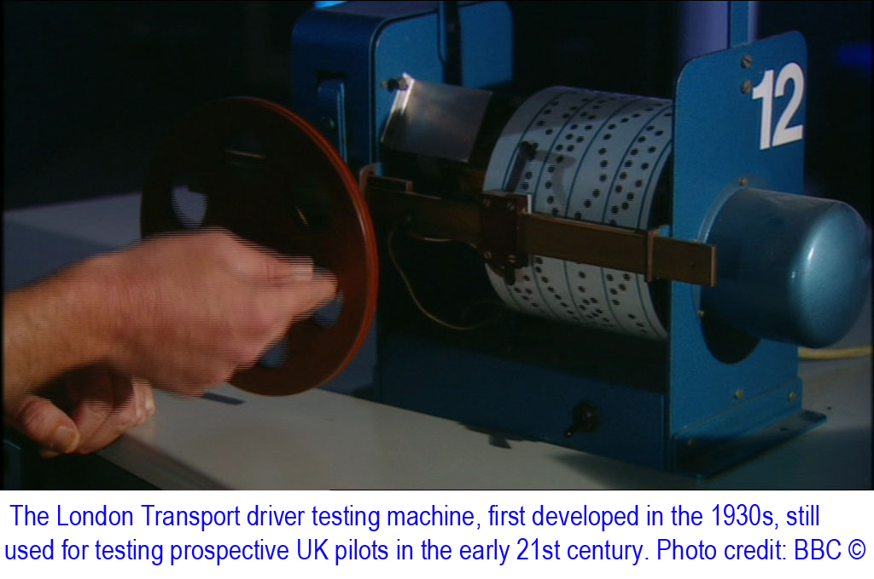

Such as test could easily be transferred onto an iPhone or iPad, and provide a simple but effective test of driver cognisance. The prospective driver would have to follow the wiggly line on the iPhone or iPad screen, which would move faster as the test progressed, effectively measuring both general cognisance (the ability to maintain a consistent pattern of functional behavior) and reaction times (the ability to adapt to sudden changes in driving conditions).
In addition to the basic test, there could be several additional elements, such as the sudden appearance of an intersection in the simulated road on the computer screen, with a requirement
- that the prospective driver slow for a GIVE WAY sign and
- stop for a STOP sign;
- that he or she move to the correct side of the road after this simulated intersection; and further,
- that he or she be aware of a large car icon moving in fast from one side of the intersection.

It is failure of these elements that appears to be the major factor in most tourist-related accidents.

Such as test could effectively weed out those who were not capable of driving safely. If they failed a test, they could be offered a second chance the next day, after some sleep and perhaps study. The government rental car database would be notified that the prospective driver had failed the test, after which he or she would be barred from either driving any vehicle, renting any vehicle or re-sitting the test for 24 hours.
A multi-lingual facsimile of this same test would be available online, so the prospective driver could study during his or her period of rest, and thus gain the skills and understanding to pass the test after a period of recuperation.

Changes to road conditions
Many accidents involving foreign drivers involve confusion about where on the road he or she is supposed to be. There are two relatively simple steps that would go some way to alleviating this confusion.
- Installation of rumble strips, especially in high risk situations. NZTA research shows that rumble strips are highly effective at alerting a driver to a potentially dangerous situation, such as drifting out of lane. Horizontal rumble strips in the road leading up to major intersections would also be an effective and affordable way of alerting drivers to the impending danger. Many drivers appear to be unaware that the intersection is even there. It is arguable that the multiple fatality caused by the Dutch businessman Appelman would not have occurred had he been aware of the STOP sign in question.
- Installation of multilingual and icon-based road signage on high risk roads and especially at intersections, to warning drivers which side of the road they should be on, and which way they should look.

Conclusion

Tourist - and local - drivers are going to continue to be injured or die unless rental car companies accept responsibility for ensuring that foreign drivers are sufficiently competent to drive on rural New Zealand roads before they hand the keys over.
In any industry, there are ethical and less-ethical companies. The ethical companies will make every effort to ensure tourist drivers can safely navigate their way round rural roads; the less ethical companies, whose staff are under heavy pressure to reach specified sales targets, may not. Rental industry legislation may be the only way to achieve this.
There must also be changes to the roading system to protect all road users from mistakes made by a small minority of drivers.

Bad Trips: International tourism and road deaths in the developing world, FIA Foundation for the Automobile and Society, http://www.makeroadssafe.org/publications/Documents/tourism-report.pdf
Tourist drivers: the truth about crashes, New Zealand Herald, 7 June 2014 http://www.nzherald.co.nz/nz/news/article.cfm?c_id=1&objectid=11269335
Tourist did not know what centre lines were for, NZ Stuff, 7 May 2014, http://www.stuff.co.nz/national/crime/10016207/Tourist-did-not-know-what-centre-lines-were-for
Dutch crash driver to pay reparation, NZ Stuff, 17 July 2014 http://www.stuff.co.nz/national/10277713/Dutch-crash-driver-to-pay-reparation
Worst drivers don’t believe it applies to them, dogandlemon.com media release, 28 April 2014 http://www.dogandlemon.com/media/worst-drivers-think-they-re-the-best-drivers-says-study
A Comedy of Errors, dogandlemon.com, 2014 http://www.dogandlemon.com/sites/dogandlemon.com/files/a_comedy_of_errors.pdf
Dare to drop D.A.R.E. and replace it with an effective program, Alcohol problems and solutions, Prof. David J. Hansen, PhD http://www2.potsdam.edu/alcohol/Controversies/1077650838.html#.VDeF2VSSzUJ
High School Driver Education and Crash Involvement, Allan F. Williams, Insurance Institute for Highway Safety http://www.iihs.org/frontend/iihs/documents/masterfiledocs.ashx?id=921
Tired drivers as bad as drunk drivers, phys.org, 21 January 2011 http://phys.org/news/2011-01-drivers-bad-drunk.html

